**CellReg - Cell registration across sessions**

The following document provides the instructions for cell registration across sessions. The registration procedure is demonstrated for a sample data set consisting of 5 imaging sessions from 5 different recording days. The procedure is handled through the following graphical user interface (GUI) in MATLAB. To initialize the GUI open the file **CellReg.m**. At this point the following GUI should open:

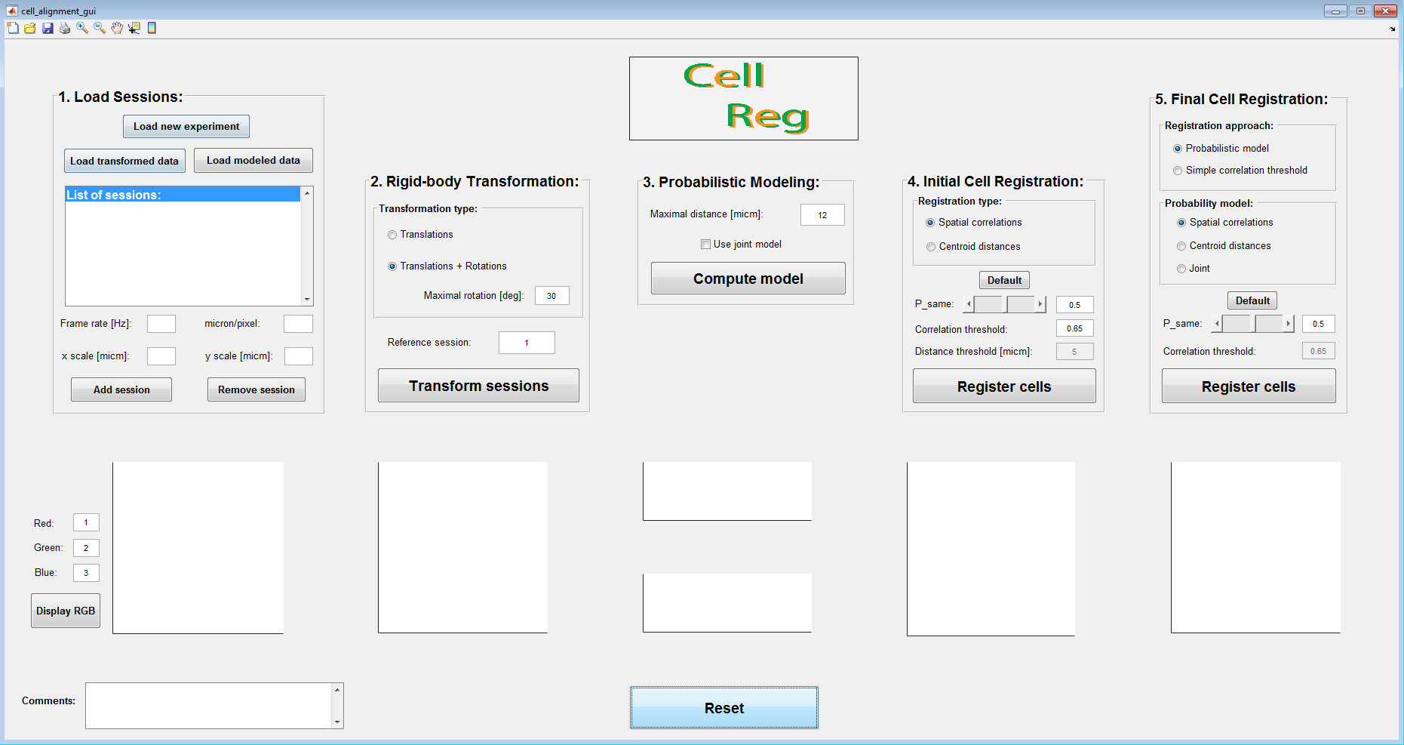

The cell registration procedure is divided into five main steps:

1. Loading the data
2. Rigid-body transformation
3. Probabilistic modeling of the data
4. Initial cell registration
5. Final cell registration

In each step one or more figures will be plotted and saved in a designated folder. At the end of each step a message will appear reporting that the step is complete.

**Structure of the inputs:**

The spatial footprints of cellular activity (ROIs) must be provided for each session separately. Two other inputs can be provided (optional) including the centroid locations (Center of masses of the spatial footprints) and Ca2+ events.

Prior to cell registration, organize your data according to the required format:

1. The matrix of the spatial footprints is of size NxMxK, where N is the number of neurons, M is the number of pixels in the y axis and K is the number of pixels in the x axis. Each entry in the matrix is equal to the corresponding pixel's value which represents its contribution to the overall cell's fluorescence.
2. The matrix of centroid locations is of size Nx2, where N is the number of neurons and the first and second columns are the centroid locations in the x axis and y axis, respectively.
3. The matrix of Ca2+ events is of size NxT, where N is the number of neurons and T is the number of frames in the Ca2+ videos. Each element is equal to 1 (or the amplitude of the event) if there is an event during that frame and 0 otherwise.

When registering your own data you can use one of two options:

1. Put all the .mat files with the detected spatial footprints of cellular activity in a single folder with the following names: Filters_1, Filters_2, …, Filters_S; where S is the number of sessions. The same format applies to centroid locations with “Locations_Si” and Ca2+ events with “Events_Si”.
2. Put the files of each session in a different folder and include “Filter”, in its name. The same format applies to centroid locations with “Locations” and Ca2+ events with “Events”.

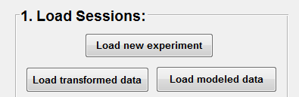**Step 1 – Loading the data:**

* 1. On the top left corner of the GUI press the **load new experiment** button.
  2. A message box will appear asking you to choose the folder containing the spatial footprints from all the sessions. Please select the folder “**SampleData**”.
  3. A question dialog will appear asking if your data include the centroids locations. Press the “**No**” button.

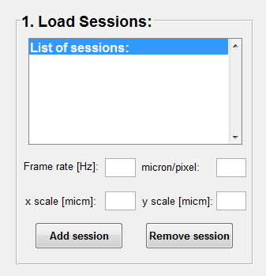

* 1. A question dialog will appear asking if your data include the events. Press the “**No**” button.
  2. A message box will appear asking for the pixel size in µm. Please insert ‘**2.3**’ in the micron/pixel field and press enter.
  3. A message box will appear asking you to choose the folder in which to save the cell registration results. Please create a new folder called “RegistrationResults” for this purpose and select this new folder.

**Step 2 – Rigid-body transformation:**

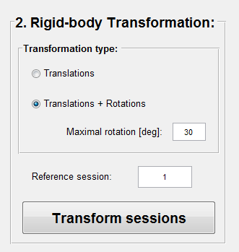

For this sample data set there is no need for rotational correction across sessions. Choose the “**Translations + Rotations**” transformation type (if only translations is required it significantly shortens the runtime), reference session “**1**” (different reference is also ok), and press the “**Transform sessions**” button.

This is the longest step and should take about 10-20 minutes.

**Step 3 – Probabilistic modeling of the data:**

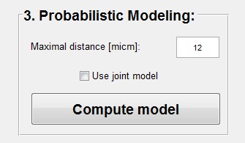

Choose maximal distance “**12**” and press the “**Compute model**” button.

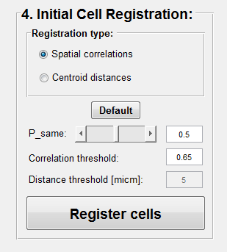

**Step 4 – Initial cell registration:**

Choose the “**Spatial correlation**” registration type and press the “**Register cells**” button. The correlation threshold is automatically set to suit the specific data set.

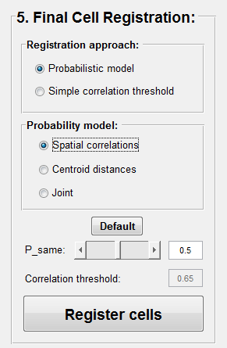

**Step 5 – Final cell registration:**

Choose the “**Probabilistic model**”, the “**Spatial correlations**” probability model, Psame threshold “**0.5**”, and press the “**Register cells**” button.

You have just finished the cell registration procedure**!**

**Results and outputs:**

The final cell registration results will be saved in the registration results folder in the file “**cellRegistered_Final_<date>_<time>.m**”. This is a MATLAB structure which includes several matrices with information regarding N registered cells from M imaging sessions:

1. “optimal_cell_to_index_map” – A matrix of size NxM, with the mapping of each registered cell to the indices in each registered session.
2. “cell_scores” – A vector of size N with the registration qualities (ranges 0-1) for all registered cells. Also included a decomposition of the scores to true positive scores, true negative scores, and exclusivity scores.
3. “is_cell_in_overlapping_FOV” – A binary vector of size N where the value is 1 if the cell was within the imaged FOV in all sessions and 0 otherwise.
4. “registered_cells_centroids” – A matrix of size Nx2 with the average centroid locations of all registered cells.
5. “all_centroids_corrected” – A cell of size M. In each cell there is a matrix of size Nix2; with the transformed centroid locations of all registered cells. Ni is the number of detected cells in the ith session.
6. “all_filters_corrected” – A cell of size M. In each cell there is a matrix of size NixMxK; with the transformed spatial footprints of all registered cells. Ni is the number of detected cells in the ith session.

A log file with all the relevant information regarding the data, registration configuration, and a summary of the registration results is saved automatically.